DRAFT Lancashire County Council Suicide Prevention Strategy

Executive summary
Insert summary

Background
Suicide is the act of intentionally ending your life(1). The factors that lead to suicide are complicated and suicide is rarely the result of a single issue. However, there are many known risk factors for suicide including male gender, middle age, mental health conditions, previous suicide and self-harm attempts, physically disabling illnesses, substance misuse and stressful life events such as bereavement, debt or family breakdown(2).
National trends in suicide
Since the 1980s, suicide rates in the United Kingdom (UK) have been decreasing, reaching a historical low in 2008-2010 (Figure 1)(2-4). Rates then increased between 2010 and 2013, a phenomenon attributed by some to the effects of the global financial crisis and the subsequent economic recession(5). This demonstrates the volatile nature of suicide rates and the need to be responsive to emerging risks(2). The most recent data from 2015 show a slight increase from the 2014 rate. However, the UK's suicide rate remains low compared to other European countries(2,3). In 2015, there were 6,188 suicides in the UK, accounting for 1.0% of all deaths(3,6).

Figure 1: Age-standardised suicide rates by sex in the UK, deaths registered between 1981 and 2015(3)
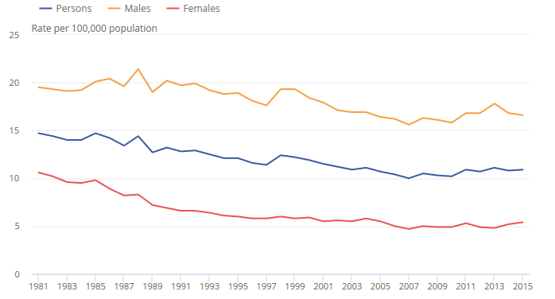
Source: Office for National Statistics, National Records of Scotland, Northern Ireland Statistics and Research Agency
Gender and age
The suicide rate amongst males is consistently around three times higher than that of females across all ages in the UK(3). Males aged 45-59 years continue to have the highest suicide rate and males aged 30-44 years the second highest, although the incidence is falling in both groups(3). In contrast, males under 30 years have the lowest male suicide rate, but this is increasing(3). Similarly, females aged 45-59 years consistently have the highest suicide rate and those aged 30-44 years the second highest(3).
Socio-economic status
As well as variation by sex, suicide rates vary considerably according to socioeconomic characteristics, with suicide rates reflecting wider inequalities. People in the lowest socioeconomic group and living in the most deprived geographical areas are ten times more likely to complete suicide than those in the highest socioeconomic group living in the most affluent areas(4).
Means of suicide
The most common method of suicide in the UK is hanging, with rates of hanging increasing in recent years, potentially as a consequence of other methods becoming less accessible; for example, the impact of catalytic converters in cars in reducing suicides by carbon monoxide poisoning(3,7). Self-poisoning is the second most common method of suicide nationally(3).

Suicide in Lancashire
Suicide rates in Lancashire are high. Amongst women under 30 years old and males under 40 years old, suicide is the leading cause of death in the county. Overall suicide rates (all persons), female suicide rates and years of life lost due to suicide (all persons, males and females) are significantly higher than the national figures and Lancashire does not perform significantly better than the national average on any suicide indicator(8). Figures released in 2016 by the Office for National Statistics (ONS) showed that between 2012 and 2014, of 326 unitary and district authorities, Preston had the highest suicide rate of all English local authorities and Hyndburn the seventh highest rate(9). Using more recent pooled data between 2013 and 2015, Preston continues to have the fourth highest suicide rate and Hyndburn the twenty-seventh highest(8).

As displayed in Figure 2, suicide rates in Lancashire were in line with national figures until 2005-2007, after which rates in Lancashire increased and have remained significantly higher than the national figure since 2007-2009. This is demonstrated by the 95% confidence intervals that do not contain the national value. This divergence from the national figure has been more pronounced for males than females, as can be seen in Figure 3. Data is presented using three-year pooled averages because these provide a more resistant measure for local data, where yearly numbers are relatively low and fluctuate widely due to random error.
Figure 2: Trend in suicide rate in England and Lancashire – all persons, 2001-2003 to 2013-2015
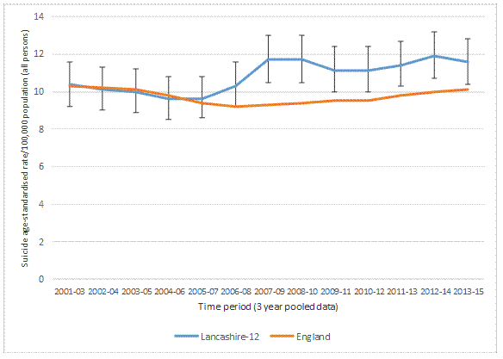
Data source: Public Health England Suicide Prevention Profile(16)
Figure 3: Trend in male and female suicide rate in England and Lancashire, 2001-2003 to 2013-2015
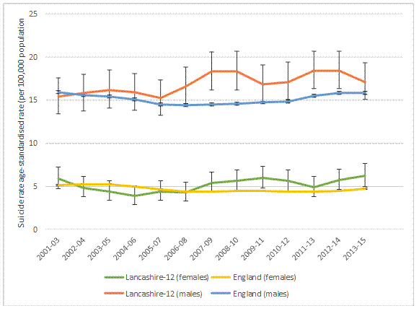
Data source: Public Health England Suicide Prevention Profile(16)
The districts of Lancashire County Council
As can be seen from Table 1 and Map 1, although the rate for Lancashire as a whole is above the national average, the only two districts where suicide rates in recent years have been above those of England are Preston and Hyndburn. Of these, it is only Preston where the rate is persistently significantly higher than the national average.

Table 1: Age-standardised mortality rate from suicide per 100,000 population, all ages, Lancashire
Area | 2003-05 | 2004-06 | 2005-07 | 2006-08 | 2007-09 | 2008-10 | 2009-11 | 2010-12 | 2011-13 | 2012-14 | 2013-15
Burnley |  | 11.4 |  | 10.8 | 12.2 | 10.5 |  |  |  | 11.3 | 11.5
Chorley |  |  |  | 13.5 | 15.8 | 14.2 | 9.7 | 8.5 |  |  | 8.7
Fylde |  |  |  |  |  |  |  |  |  | 11.8 | 11.7
Hyndburn |  |  |  |  | 12.0 |  | 12.7 | 14.6 | 14.5 | 16.3 | 13.7
Lancaster | 9.2 | 7.8 | 8.5 | 9.4 | 8.6 | 9.2 | 9.9 | 11.8 | 11.1 | 11.8 | 12.2
Pendle | 12.1 |  |  |  |  | 12.3 | 11.1 | 10.9 | 12.2 | 13.7 | 12.4
Preston | 11.3 | 11.8 | 13.0 | 12.0 | 15.9 | 13.8 | 14.6 | 14.6 | 16.7 | 18.6 | 16.8
Ribble Valley
Rossendale |  |  | 15.8 | 15.2 | 19.3 | 17.1 | 17.3
South Ribble | 11.7 | 12.9 | 11.1 | 10.1 |  | 9.4 | 11.2 | 14.6 | 14.6 | 13.5 | 11.3
West Lancashire | 9.7 |  |  |  | 9.3 | 9.3 | 9.1 | 8.8 | 10.9 | 9.6 | 8.7
Wyre | 10.3 |  |  | 10.0 | 11.7 | 13.7 | 11.7 | 10.1 |  | 10.4 | 9.2
Lancashire-12 | 10.0 | 9.6 | 9.6 | 10.3 | 11.7 | 11.7 | 11.1 | 11.1 | 11.4 | 11.9 | 11.6
England | 10.1 | 9.8 | 9.4 | 9.2 | 9.3 | 9.4 | 9.5 | 9.5 | 9.8 | 10.0 | 10.1
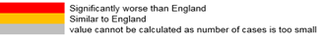
Source: Public Health England, Public Health Outcomes Framework

Map 1: Map showing mortality rate (2013-2015) from suicide across Lancashire
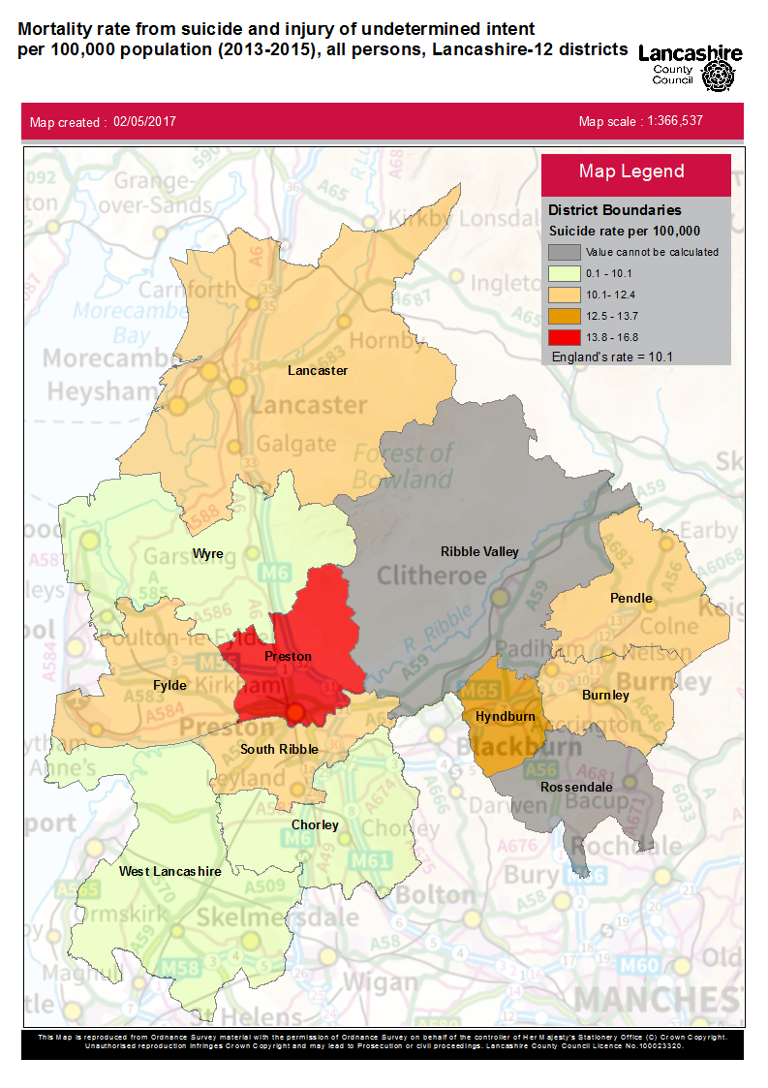
Data source: Public Health England, Public Health Outcomes Framework

Hospital admissions from intentional self-harm
Self-harm is an expression of personal distress. Following an episode of self-harm, there is a significant and persistent risk of future suicide. In Lancashire, the most recent figures (2015/16) demonstrate that the rate of hospital admissions for self-harm for the county remains significantly worse than the England rate. Looking at individual districts, presented in Table 2, the rates in Burnley, Chorley, Fylde, Hyndburn, Lancaster and Wyre are consistently significantly worse than the England rate. As previous self-harm is the most powerful predictor of future suicide, this demonstrates that action is needed across Lancashire and not just in areas where rates of completed suicide are high.

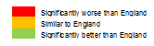
Table 2: Emergency hospital admissions for intentional self-harm, all ages, all persons, Lancashire
District | 2012/13 | 2013/14 | 2014/15 | 2015/16
Burnley | 345.9 | 332.9 | 345.1 | 294.6
Chorley | 218.2 | 289.7 | 243.4 | 233.6
Fylde | 266.3 | 203.6 | 242.7 | 257.0
Hyndburn | 317.6 | 341.1 | 309.5 | 295.0
Lancaster | 316.6 | 290.5 | 278.6 | 274.0
Pendle | 235.0 | 277.5 | 217.9 | 206.2
Preston | 224.9 | 247.1 | 192.5 | 200.3
Ribble Valley | 153.8 | 190.9 | 203.8 | 188.0
Rossendale | 235.1 | 286.4 | 240.5 | 222.0
South Ribble | 188.6 | 196.6 | 138.0 | 189.4
West Lancashire | 234.0 | 225.2 | 218.9 | 204.7
Wyre | 237.2 | 273.8 | 264.4 | 277.5
Lancashire-12 | 246.8 | 260.8 | 236.1 | 235.0
England | 189.6 | 205.9 | 193.2 | 196.5
Source: Public Health England, Public Health Outcomes Framework

Existing work to address suicide in Lancashire
It has been recognised for some time that rates of suicide and self-harm in Lancashire are high and are above the national average. Much work has already been done and is ongoing within Lancashire County Council and with partners to address this.
Suicide audit
A large suicide audit encompassing the two year period between April 2013 and March 2015 has recently been completed. The purpose of this project was to examine in depth each individual suicide that had occurred within the twelve districts of Lancashire County Council in order to determine trends and themes that are not accessible through routinely available data and that may differ from the national picture. This allows lessons to be learnt that help to prevent future suicides in Lancashire. Over the course of this project, case files from 222 suicides were reviewed and the data generated informs much of this strategy. Some of the key themes from this piece of work were as follows:
Demographics
- In the audit cohort, deaths from suicide were highest in the 40-49 and 50-59 year age groups; and nearly 2.5 times higher in males than in females.
- The majority of suicides were of White British ethnicity but the representation of White Other ethnicity in the audit cohort, which primarily consisted of Eastern Europeans, was higher than its representation in the Lancashire population.
- 23% of the deceased were unemployed at time of death, compared to between 5-7.7% of the wider Lancashire population during the audit period.

Deprivation and geography
- A significantly higher proportion of the deceased resided in the 20% most deprived areas compared to the 20% least deprived areas.
- There were more suicides amongst the youngest age groups in the most deprived areas, whilst there were more suicides amongst the oldest age groups in the least deprived areas.

Circumstances of death
- 70% of the deceased were single, divorced, separated or widowed and 43% were living alone at time of death, suggesting high levels of social isolation.
- Hanging was the most common method of suicide, followed by self-poisoning.
- Of those who took their life by self-poisoning, 40% had used opiates (primarily prescribed painkillers), 30% had used tricyclic antidepressants and the most common source of substances was prescribed for the subject.
- The top factors contributing to suicide were: mental illness, financial difficulties, relationship breakdown, substance misuse, bereavement (including bereavement by suicide), ongoing criminal investigation/recent police contact and abuse.
- Where there was an ongoing criminal investigation or recent police contact, the most common offence was child sex offences.

Mental health diagnoses and contact with services
- A quarter of the deceased had either visited their GP for a mental health condition or been seen by specialist mental health services in the week before their death.
- Compared with females (77%), a lower proportion of males (63%) had a mental health diagnosis and multiple GP consultations for mental health problems during the previous 12 months; suggesting that males may be less likely to seek and receive support.
- Depression, anxiety disorders and substance misuse were the three most common mental health diagnoses amongst the audit cohort.
- 46% of the deceased had a history of contact with mental health services.
- 41% of the deceased had a history of self-harm and 43% of the deceased had a history of alcohol and/or drug misuse.
- 12% of all individuals, and 25% of all females, had been victims of physical or sexual abuse.
- Aside from health services the most common other agencies that individuals had been in contact with were the police, substance misuse services and social services.
The full suicide audit report can be accessed via the Lancashire County Council website (insert hyperlink when published online).

The Lancashire and South Cumbria Sustainability and Transformation Plan
Health partners in English regions have been required to develop Sustainability and Transformation Plans (STPs) that address national priorities, including suicide(9). Analysis within the 'National Confidential Inquiry into Suicide and Homicide by People with Mental Illness' demonstrated that of the 44 STP footprints across England, Lancashire and South Cumbria had the second highest suicide rate in 2012-2014 (12.6 per 100,000 population)(10). An STP suicide prevention oversight group and an STP suicide prevention delivery group have been formed and Lancashire County Council is represented on both.
Insert detail of work underway with the STP suicide prevention group

Insert detail of other work projects/partnership working relevant to suicide prevention

Vision for the future

Policy context
Suicide prevention is currently a national priority and there are several policy documents, both national and local that set the vision for suicide prevention in England:
"The Five Year Forward View for Mental Health"
The 'Five Year Forward View for Mental Health' highlighted suicide prevention as a key area for improvement, with a national target for the number of people taking their own life in each local area to have reduced by 10% in 2020/21 compared to 2016/17 levels(9).
"Preventing suicide in England: a cross-governmental outcomes strategy to save lives"
The current key national strategy document within suicide prevention is 'Preventing suicide in England: a cross-governmental outcomes strategy to save lives'(2). This sets out the government's strategy to prevent suicide in England and focuses on six key areas(2):
- Reduce the risk of suicide in key high-risk groups;
- Tailor approaches to improve mental health in specific groups;
- Reduce access to the means of suicide;
- Provide better information and support to those bereaved or affected by suicide;
- Support the media in delivering sensitive approaches to suicide and suicidal behaviour and
- Support research, data collection and monitoring.

There have been regular reports on national progress against this strategy, with the most recent published in January 2017(11). Here, self-harm was added to the strategy as a separate key area for focus, in recognition of the fact that self-harm is the biggest indicator of suicide risk(11). Indeed, half of people who complete suicide have a history of self-harm(11).
"No health without mental health"
This national suicide prevention strategy runs alongside the government's wider mental health strategy 'No health without mental health'(12). This recognised that, although the quality of mental health care has improved in recent years, too much emphasis has been placed on structures and processes rather than outcomes(12). The strategy set shared national objectives to improve services and to transform public attitudes towards mental health(12). A key measure within the strategy was that fewer people should suffer avoidable harm, with suicide rates placed within the Public Health Outcomes Framework(12).
"The Lancashire and South Cumbria Sustainability and Transformation Plan"
Nationally, the suicide component of STPs is required to focus strongly on primary care, substance misuse and to incorporate evidence-based preventative interventions that target high-risk locations and high-risk groups within their population, drawing on localised real-time data(9). Suicide sits within the prevention work stream of the Lancashire and South Cumbria STP, which has prioritised prevention and early intervention to reduce suicide(13).

Our strategic objectives
Our vision for the future is to reduce suicide rates in Lancashire at a county-wide level both through targeted interventions aimed at those at the highest risk of suicide and through more upstream initiatives that seek to improve the wellbeing of the Lancashire population and that have wider societal benefits. In line with the national target, by 2021 we aim to have reduced the number of people completing suicide in Lancashire by 10% compared to 2016/17 rates.
To achieve this vision, we will adopt the strategic objectives of the national suicide prevention strategy ("Preventing suicide in England: a cross-governmental outcomes strategy to save lives")(2):
- Reduce the risk of suicide in key high risk groups;
- Tailor approaches to improve mental health in specific groups;
- Reduce access to the means of suicide;
- Provide better information and support to those bereaved or affected by suicide;
- Support the media in delivering sensitive approaches to suicide and suicidal behaviour and
- Support research, data collection and monitoring.

In order to ensure that these objectives are relevant to the twelve districts of Lancashire County Council, our approach to each of these objectives will be determined by local data, including that generated through our recent Lancashire Suicide Audit, as well as the wider evidence base. This methodology will help to ensure that our strategy is both in alignment with national and local agendas, as the Lancashire and South Cumbria STP suicide plans are also structured around the national objectives, and is locally applicable.

Action plan
- Reduce the risk of suicide in key high risk groups:
- Young and middle-aged men;
- People in the care of mental health services, including inpatients;
- People with a history of self-harm;
- People in contact with the criminal justice system and
- Specific occupational groups such as doctors, nurses, veterinary workers, farmers and agricultural workers.
As demonstrated by the suicide audit, the most pertinent high-risk groups in Lancashire are young and middle-aged men, people with a history of self-harm (including previous suicide attempts), people in contact with the criminal justice system (most notably child sex offenders) and people in contact with mental health services. No specific occupational groups were highlighted as being at-risk, potentially because of the small numbers of each occupational group involved.

  - Young and middle-aged men
Action point 1: Offer services for men and train staff in community locations in Lancashire away from formal healthcare settings.
Action point 2: Develop local campaigns to reduce the stigma of mental illness and suicide building on current national momentum, such as the "Time to Talk" campaign.
Action point 3: Invest in initiatives to reduce male unemployment in Lancashire.
  - People with a history of self-harm
Action point 4: Emergency Departments and secondary care to be represented on the local multi-agency suicide prevention group.
Action point 5: Local pathways for the assessment, management and follow-up of people presenting to Emergency Departments with self-harm to be reviewed and, if required, integrated mental health care pathways to be developed between mental health liaison teams in secondary care and community services.
Action point 6: Training on suicide prevention for clinical staff in Lancashire on aspects pertinent to their work, such as self-harm risk assessment and safe prescribing, through existing programmes of professional education.
1.3.People in contact with the criminal justice system
Action point 7: Lancashire Constabulary to review and strengthen their risk assessment, checks and safety netting procedures for when individuals leave custody, particularly amongst those suspected of child sex offences.
  - People in contact with mental health services
Action point 8: All agencies represented on the local multi-agency suicide steering group to pledge to ongoing financial commitment to mental health.
Action point 9: Mental health services in Lancashire should be joined up with employment services to allow both mental health and employment needs to be addressed.
Action point 10: Targeted interventions and services to enable people with mental health conditions in Lancashire to return to or enter the workplace.
Action point 11: Mental health services in Lancashire to review their operating procedures and explore approaches to integrated working and information sharing.

- Tailor approaches to improve mental health in specific groups:
- Children and young people;
- Survivors of abuse or violence;
- Veterans;
- People living with long-term physical health conditions;
- People with untreated depression;
- People who are especially vulnerable due to social and economic circumstances;
- People who misuse drugs or alcohol;
- Lesbian, gay, bisexual and transgender (LGBT) people and
- Black, Asian and minority ethnic groups and asylum seekers.
Several specific groups were highlighted within the national suicide prevention strategy as requiring tailored approaches to improve mental health. Of these specific groups, those that emerged as at particularly high risk of suicide in Lancashire were survivors of abuse or violence, people living with long-term physical health problems, people vulnerable due to social and economic circumstances and people who misuse drugs or alcohol. In addition, although there were very small numbers of children and young people represented in the audit, it was noted that many of the contributory factors to suicide, such as sexual abuse or bereavement by suicide, had occurred during childhood and adolescence. Consequently, this group is a key focus for suicide prevention. With regards to the other groups highlighted within the national strategy, such as LGBT people and veterans, although these are likely to represent key areas for suicide prevention nationally, there were very few individuals within these groups in the audit cohort.

  - Survivors of abuse or violence
Action point 12: Ensure that there is integration between the multi-agency suicide prevention group in Lancashire and the Pan-Lancashire Strategic Domestic Abuse Board.
  - People with long-term physical health problems
Action point 13: Training for primary and secondary care clinicians to recognise and manage the mental health implications of physical illness.
Action point 14: Integrated management pathways for physical and mental health, including routine mental state assessment, self-care advice and referral to services and organisations that address social isolation as part of the regular review for chronic conditions such as osteoarthritis and respiratory disease.
2.3 People vulnerable due to social and economic disadvantage
Action point 15: Form and build on existing partnerships with local organisations that work with deprived communities.
Action point 16: Provide public information to signpost people to information and support if they are in debt or at risk of getting into debt, advice on maintaining wellbeing during difficult times and guidance on where to go for further help.
Action point 17: Ensure that healthcare professionals in primary care, secondary care and mental health settings are aware of services relating to financial support and debt prevention/management to enable them to signpost patients presenting with low mood, anxiety or suicidal thoughts as a result of financial difficulties.
Action point 18: Training for staff in services such as housing and Welfare Rights that regularly encounter people at high-risk of suicide to manage self-harm and suicide declarations and develop frameworks to support these.
2.4 People who misuse drugs or alcohol
Action point 19: Specific consideration and mention of suicide prevention in drug and alcohol strategies in Lancashire to ensure that work on substance misuse is fully aligned with suicide prevention.
Action point 20: Joint responsibility between substance misuse and mental health services in Lancashire for treating both substance misuse and other mental health conditions.
Action point 21: Training on suicide prevention and interventions for staff working in addiction services in Lancashire.
Action point 22: Work with CCGs and hospital trusts in Lancashire to incorporate suicide risk into brief interventions for harmful drinkers.
Action point 23: Engage people with experience of substance misuse and self-harm or suicide attempts in service design and delivery; for example, through the Lancashire User Forum or the Recovery Infrastructure Organisation.
2.5 Children and young people
Action point 24: Sustained investment and commitment to universal children's services in Lancashire.
Action point 25: Sustained investment and commitment to specialist children's services in Lancashire and those that work with vulnerable children, such as children's social care, CAMHS and the Lancashire County Council Children and Family Wellbeing service.

- Reduce access to the means of suicide
Those methods of suicide most amenable to reduced access are hanging and strangulation in inpatient/criminal justice settings, self-poisoning, deaths that occur at high-risk locations and on the rail network.
There were less than five deaths by hanging or strangulation in inpatient/criminal justice settings in Lancashire during the suicide audit period, however self-poisoning was the second most common method of suicide and is a highly relevant area for action, with the majority of deaths occurring as a result of prescribed substances. The suicides that occurred on the rail network during the audit period were spread across the county with no hotspots, however there were three public locations where more than one suicide had been completed.
Action point 26: Training of GPs in Lancashire regarding safe prescribing of analgesia and antidepressants, particularly at times of high risk.
Action point 27: Work with GPs and pharmacists in Lancashire to ensure that there are effective medicines management strategies to highlight non-compliance and diversion of medications.
Action point 28: Engagement of the Lancashire Medicines Management Group to support safe prescribing of analgesia and antidepressants in Lancashire.
Action point 29: Where individuals disclose suicidal thoughts, risk assessment should include assessment of the means of suicide and attempts to remove and relinquish the means; for example, medication review.
Action point 30: Lancashire multi-agency suicide group to review interventions in place at suicide hotspots in Lancashire.
- Provide better information and support to those bereaved or affected by suicide
Bereavement is known to be a risk factor for suicide and this risk is increased where people have been bereaved by suicide(14). Of those completing suicide during the audit period in Lancashire, several had a recorded history of suicide in a close family member.
Action point 31: To work with existing support organisations, for example 'Survivors of Bereavement by Suicide', to offer support to Lancashire residents affected by suicide via existing groups and new support networks to ensure that there is specialist suicide bereavement support available across the county.
Action point 32: To develop routine pathways and information packs for all families bereaved by suicide that could be disseminated via GPs or the relevant coroner's office.

- Support the media in delivering sensitive approaches to suicide and suicidal behaviour
The media has an important role to play in influencing suicidal behaviour. Where there is a high profile death, media reporting can result in imitative behaviour, particularly at suicide hotspots and clusters of suicides. In addition, internet content promoting suicide, detailing effective methods of suicide or making available the means of suicide can influence peoples' decision to attempt suicide and the effectiveness of their attempts. This is a recognised offence and individuals can be prosecuted(2). Internet content had played a role amongst seven people within the audit cohort and is especially relevant to suicides amongst young people.
Action point 33: Where internet content is identified as being a factor in the suicide, either by the police or during the Coroner's investigation, Lancashire Constabulary should support the internet industry to remove the content.
Action point 34: Where websites, including people in online chat rooms and social networks, are found to be persistently promoting suicide or suicide methods, Lancashire Constabulary should seek prosecutions.
Action point 35: To improve and develop the suicide component of Lancashire County Council's website as a reliable source of support and resources, linking to third party websites where appropriate.
Action point 36: The multi-agency suicide prevention group should proactively engage the local media to develop a standard for reporting suicides responsibly.

- Research, data collection and monitoring
Robust and reliable research, data collection and monitoring are crucial when developing any meaningful suicide prevention strategy. Although suicide audit enables in-depth exploration of each depth, there was a delay of months and in some cases years between the death occurring and the process of suicide audit. Real-time surveillance enables the multi-agency group to rapidly implement interventions in response to cases of suicide or self-harm; for example, to respond to clusters in suicide hotspots, to become aware of new methods of suicide and ensure that support is provided to the bereaved.
Action point 37: Local multi-agency suicide prevention group to explore with the Lancashire coroners the possibility and practicality of establishing real-time suicide surveillance in Lancashire.
Action point 38: Local multi-agency group to explore the possibility and practicalities of real-time self-harm surveillance in Lancashire.
Action point 39: If future suicide audits are carried out in Lancashire, an adapted suicide audit proforma should be adopted that has been standardised with other local authorities within the Lancashire and South Cumbria STP footprint in order to improve data collection and comparibility.
Action point 40: Engage people affected by suicide and staff working in mental health services to inform deeper aspects of suicide prevention.

Monitoring progress
Monitoring progress against this strategy, including yearly reports against the strategyis planned across Lancashire and South Cumbria STP footprint. In 2021 the strategy will be formally evaluated and progress in terms of the 10% reduction target will be assessed.

References
- NHS Choices. Suicide. 9 February 2015. Available at: http://www.nhs.uk/conditions/Suicide/Pages/Introduction.aspx. (Accessed 18 January 2017).
- HM Government. Preventing suicide in England: a cross-governmental outcomes strategy to save lives. 10 September 2012. Available at: https://www.gov.uk/government/uploads/system/uploads/attachment_data/file/430720/Preventing-Suicide-.pdf. (Accessed 18 January 2017).
- Office for National Statistics. Suicides in the United Kingdom: 2015 registrations. 2 December 2016. Available at: https://www.ons.gov.uk/peoplepopulationandcommunity/birthsdeathsandmarriages/deaths/bulletins/suicidesintheunitedkingdom/2015registrations (Accessed 8 May 2017).
- Public Health England. Local suicide prevention planning. A practice resource. October 2016. Available at: https://www.gov.uk/government/uploads/system/uploads/attachment_data/file/564420/phe_local_suicide_prevention_planning_a_practice_resource.pdf. (Accessed 2 December 2016).
- Reeves A, McKee M, Stuckler D. Economic suicides in the Great Recession in Europe and North America. Br J Psychiatry 2014 Sep;205(3):246-247.
- Office for National Statistics. Deaths by single year of age tables - UK. 13 July 2016. Available at: https://www.ons.gov.uk/peoplepopulationandcommunity/birthsdeathsandmarriages/deaths/datasets/deathregistrationssummarytablesenglandandwalesdeathsbysingleyearofagetables. (Accessed 08 May 2017).
- Routley VH, Ozanne-Smith J. The impact of catalytic converters on motor vehicle exhaust gas suicides. Med J Aust 1998 Jan 19;168(2):65-67.
- Public Health England. Suicide Prevention Profile. 2016. Available at: http://fingertips.phe.org.uk/profile-group/mental-health/profile/suicide/data#page/1/gid/1938132828/pat/6/par/E12000002/ati/102/are/E06000009/iid/41001/age/285/sex/4. (Accessed 2 December 2016).
- NHS England. Implementing the five year forward view for mental health. 1 February 2016. Available at: https://www.england.nhs.uk/wp-content/uploads/2016/02/Mental-Health-Taskforce-FYFV-final.pdf. (Accessed 18 January 2017).
- Healthcare Quality Improvement Partnership. The National Confidential Inquiry into Suicide and Homicide by People with Mental Illness. October 2016. Available at: http://research.bmh.manchester.ac.uk/cmhs/research/centreforsuicideprevention/nci/reports/2016-report.pdf. (Accessed 5 April 2017).
- HM Government. Preventing suicide in England: third progress report of the cross-governmental strategy to save lives. 9 January 2017. Available at: https://www.gov.uk/government/uploads/system/uploads/attachment_data/file/582117/Suicide_report_2016_A.pdf. (Accessed 7 April 2017).
- HM Government. No health without mental health. A cross-government mental health outcomes strategy. February 2011. Available at: https://www.gov.uk/government/uploads/system/uploads/attachment_data/file/213761/dh_124058.pdf. (Accessed 19 December 2015).
- Healthier Lancashire and South Cumbria. Healthier Lancashire and South Cumbria Sustainability and Transformation Plan 2016/17-2020/21. Draft. Third submission to NHS England. 21 October 2016. Available at: http://www.lancashiresouthcumbria.org.uk/sustainability-and-transformation-plan. (Accessed 18 January 2017).
- Pitman AL, Osborn DP, Rantell K, King MB. Bereavement by suicide as a risk factor for suicide attempt: a cross-sectional national UK-wide study of 3432 young bereaved adults. BMJ Open 2016 Jan 26;6(1):e009948-2015-009948.

